**PROJECT**

INSIGHT STREAM: NAVIGATE THE NEWS LANDSCAPE

TEAM ID: NM2025TMID39855

TEAM SIZE: 4

TEAM LEADER: JAYA LAKSHMI.R

MAIL ID: jayakuttyma0727@gmail.com

TEAM MEMBER: DHARSHINI.G

MAID ID: dharshu000@gmail.com

TEAM MEMBER: THRISHA.S

MAIL ID: thrishapushpa23@gmail.com

TEAM MEMBER: SRINITHI.V

MAIL ID: [veeraveerakavitha@gmail.com](mailto:veeraveerakavitha@gmail.com)

**INSIGHTSTREAM:**

**NAVIGATE THE NEWS LANDSCAPE**

1. **INTRODUCTION**

In an era of information overload, Insight Stream emerges as a beacon of

clarity—empowering users to explore, evaluate, and engage with the news like never before.

This project is designed to help individuals navigate the complex media ecosystem, cutting

through noise and bias to uncover meaningful insights.

Whether you’re a casual reader, a student, or a media analyst, Insight Stream offers a dynamic

platform that:

• �� Aggregates diverse sources to present a balanced view of current events

• �� Analyses narratives and trends to reveal underlying patterns and perspectives

• �� Encourages critical thinking through interactive tools and guided exploration

• �� Visualizes news flows to help users understand how stories evolve and spread

By combining technology, media literacy, and thoughtful design, Insight Stream transforms

passive consumption into active understanding. It’s not just about staying informed—it’s

about becoming empowered.

**2. PROJECT OVERVIEW**

The internet is filled with massive amounts of news and information, but users often find it

challenging to identify reliable sources and extract meaningful insights. Insight Stream is

designed to help users navigate this vast news landscape in an intuitive and organized way. It

provides real-time aggregated news, personalized feeds, and a clean, interactive interface for

users to stay informed without information overload.

**Purpose:**

The purpose of this project is to create a web-based application that aggregates news from

different sources, organizes it into categories, and presents it in a simple yet powerful

interface. The system also personalizes recommendations based on user interests, enabling

users to discover stories that matter most to them.

** Key Features:**

**Features of Insight Stream:**

• News from API Sources: Access a vast library of global news spanning various

categories and interests, ensuring a well-rounded coverage of current affairs.

• Visual News Exploration: Discover breaking stories and explore different news

categories through curated image galleries, enhancing the visual appeal of news

discovery.

• Intuitive Design: Navigate the application seamlessly with a clean, modern interface

designed for optimal user experience and clarity in information presentation.

• Advanced Search Feature: Easily access news articles on specific topics through a

powerful search feature, providing users with tailored news content based on their

interests.

1. **ARCHITETURE**

**Frontend:**

Built using React.js for building dynamic user interfaces.

Bootstrap and Material UI are used for responsive design and clean styling.

**Backend:**

Developed with Node.js and Express.js to handle API requests, authentication, and business

logic.

Provides REST APIs for news, authentication, and user data management.

**Database:**

MongoDB is used for storing user information, bookmarks, preferences, and activity logs.

**High-Level Flow:**

1. User interacts with the frontend (React.js).

2. Frontend communicates with backend APIs (Node.js + Express).

3.Backend fetches news data from external APIs and stores necessary data in MongoDB.

4.User receives a personalized and structured news feed.

1. **SETUP INSTRUCTION**

**Prerequisites:**

Before running the project, ensure the following tools and technologies are installed on your

system:

Node.js: JavaScript runtime environment used for running the backend.

MongoDB: NoSQL database for storing user data, news bookmarks, and preferences.

Git: Version control system for managing source code.

React.js: JavaScript library used for building the frontend user interface.

Express.js: Backend framework for handling APIs and server logic.

Mongoose: ODM (Object Data Modeling) library for MongoDB, used to manage database

schemas.

Visual Studio Code (or any IDE): Recommended editor for coding and debugging.

**Installation Steps:**

**1. Clone the Repository**

git clone [your-repo-link]

**2. Install Frontend Dependencies**

cd client

npm install

**3. Install Backend Dependencies**

cd server

npm install

1. **FOLDER STRUCTURE**

Insight Stream/

│── client/ # React frontend

│ ├── components/ # Reusable UI components

│ └── pages/ # Page-level components

│

│── server/ # Node.js backend

│ ├── routes/ # API routes

│ ├── models/ # MongoDB schemas

│ └── controllers/ # Business logic

1. **RUNNING THE APPLICATION**

Once the setup is complete, run both frontend and backend servers.

**Frontend:**

cd client

npm start

This will launch the React frontend.

**Backend:**

cd server

npm start

This will start the Express backend server.

**Accessing the Application:**

Open your browser and go to:

<http://localhost:3000>

**7. API DOCUMENTATION**

**User APIs:**

Register User:

POST /api/user/register → Registers a new user in the system.

Login User:

POST /api/user/login → Authenticates user and returns a JWT token.

**News APIs:**

Fetch Latest News:

GET /api/news/fetch → Retrieves the latest trending news articles.

Fetch News by Category:

GET /api/news/category/:type → Fetches news by category (e.g., politics, sports,

technology).

Search News:

GET /api/news/search/:query → Returns news articles based on user search keywords.

POST /api/bookmarks/add → Saves an article to user bookmarks.

Retrieve Bookmarks:

GET /api/bookmarks/:userId → Fetches saved articles for a user.

1. **AUTHENTICATION**

Authentication in Insight Stream: Navigate the News Landscape is implemented using JWT

(JSON Web Token) to provide secure access and protect private routes.

User Registration: When a user signs up, their details are stored in the database. Passwords

are hashed for security so they are never stored in plain text.

User Login: During login, the system verifies the credentials. If correct, the server generates a

JWT token that contains the user’s ID, email, and an expiry time.

Token Usage: This token is sent by the client in the Authorization Header whenever the user

tries to access protected features like bookmarks or preferences.

Middleware Verification: A middleware function checks whether the token is valid.

If valid → user is granted access.

If invalid or expired → access is denied with an error message.

By using JWT, the system ensures that only authenticated users can use personalized features

while keeping the platform safe, fast, and reliable.

**9. USER INTERFACE**

The User Interface of Insight Stream is designed to be simple, interactive, and user-friendly

so that users can easily explore, read, and manage news articles. The UI follows a clean

layout with easy navigation and responsive design for both desktop and mobile devices.

Main Components of the Interface:

**1. Landing Page**

Displays trending and top headlines from different categories.

Provides a quick overview of the most important stories of the day.

Includes a navigation bar with links to Home, Categories, Dashboard, and Login/Register.

**2. Dashboard (Personalized Feed)**

Shows news articles based on the user’s preferences and reading history.

Includes filtering options (by category, date, or source).

Highlights saved or recommended articles for quick access.

**3. Category Pages**

News is divided into categories such as:

Politics

Technology

Sports

Entertainment

Health

Business

Each category page lists articles with headlines, short descriptions, and “Read More” links.

**4. Search and Filter Section**

Provides a search bar for finding news articles by keyword.

Allows users to filter results by date, publisher, or relevance.

**5. Bookmarks Page**

Users can save important articles for future reading.

Saved articles are listed with options to delete or revisit them anytime.

Available only for logged-in users.

**6. User Authentication Pages**

Login Page: Allows existing users to log in with email and password.

Register Page: Enables new users to create an account.

Forms include validation messages for incorrect inputs.

**7. Admin Panel (For Admin Users)**

Accessible only by admin accounts.

Allows admins to manage user accounts, monitor API performance, and ensure smooth

running of the system.

Provides system statistics (like number of users, articles fetched, etc.).

**8. Responsive Design**

The UI adapts to different screen sizes (desktop, tablet, and mobile).

Navigation collapses into a hamburger menu on smaller devices for better accessibility.

**10. TESTING**

**Manual Testing:**

Testing was performed at every development milestone to ensure reliability and stability of

the system. Each feature such as:

User Registration &amp; Login

Fetching News from APIs

Bookmarking Articles

UI Navigation and Responsiveness

was manually tested to confirm correct functionality.

**Tools used:**

**Chrome Developer Tools:**

Used for debugging UI/UX issues, checking responsiveness on multiple devices, monitoring

API calls, and fixing console errors.

**Postman:**

Utilized for testing backend API endpoints like user authentication, fetching news, and

managing bookmarks.

**11. Screenshot**

1. 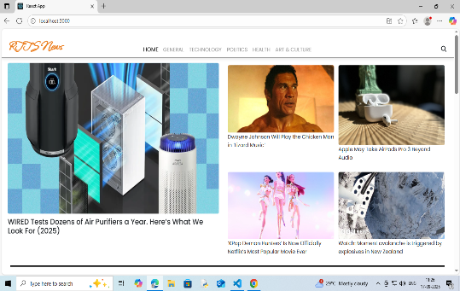 **HOME:**

**2. GENERAL:**

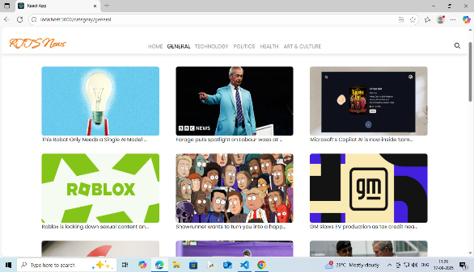

**3.TECHNOLOGHY:**

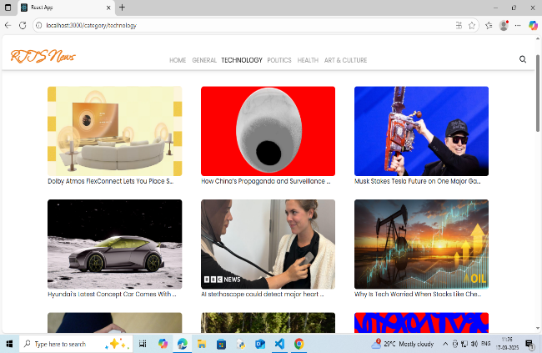

**4.POLITICS:**

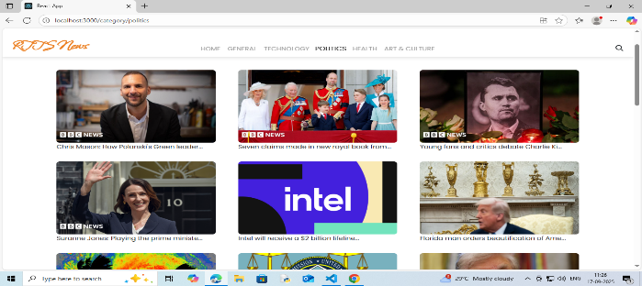

**5. HEALTH:**

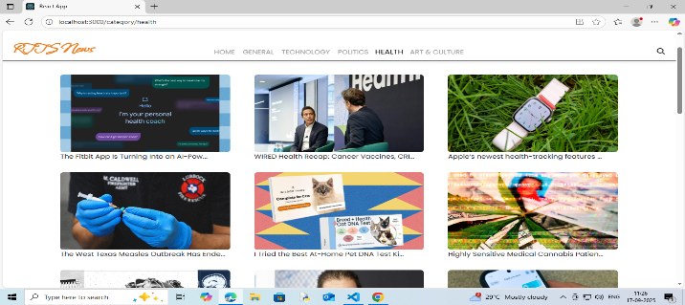

1. **ARTS & CULTURE:**

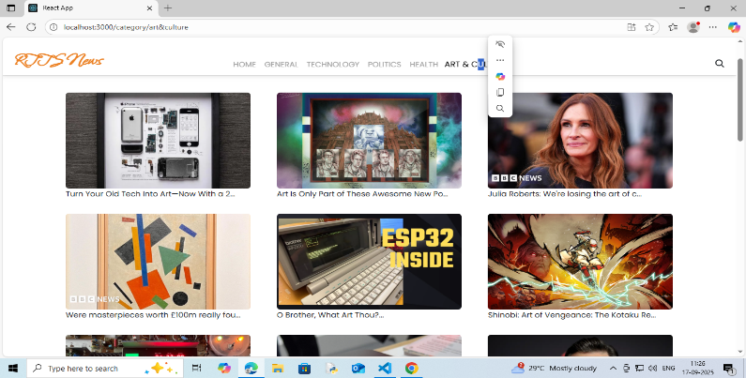

1. **SUBCRIBES:**

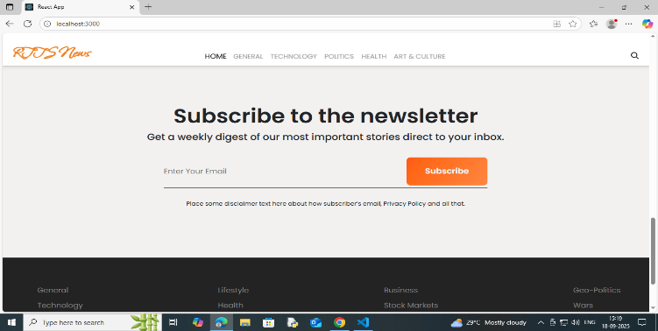

**12. KNOWN ISSUES**

1. **DATA SOURCE LIMITATIONS:**

**Some new feeds may not refresh in real -time due to API rate**

**Limits or downtime.**

1. **SEARCH & FILTERING:**

**Search result may occasionally return outdated articles if the cache**

**Hasn’t refreshed.**

**13. FUTURE ENHANCEMENTS**

1. **ADVANCED PERSONALIZATION:**

AI-driven recommendation tailored to user reading habits.

1. **REAL-TIME ANALYTICS:**

Live trend analysis of breaking news.